Project:
You will have nine cards hanging from your mobile and one at the top (ten total). Their shape and size is your decision. Each card needs to have the information as well as a picture. The picture should relate to the information on the card.
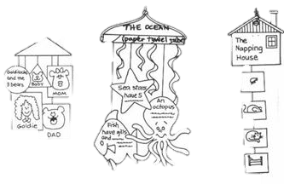
Each card should be clearly labeled and easy to identify.
The ten cards are:
- Title and Author of the book you read.
(this one goes at the top)
- Main Characters (with their names and character traits)
- Setting (time and place) that the story takes place.
- Conflict (what was the problem that happened in the story).
- Solution (how did the characters solve the problem).
- Favorite Part of the story
- One connection that you made (Text-Text, Text-World or Text-Self).
A sentence about what happened in the story. A sentence about what happened to you. A sentence about how they are related.
- Theme or Message (What does the author want you to remember)
- Personal Opinion of the book and why you liked or did not like it.

Make sure that your whole project is Fourth Grade Quality and that it shows how much time you took to work on it. Make a project you are proud of and want to keep in your room or show off to your grandparents!

Tips:
*Do NOT read your cards during the presentation, rather TELL them about the book and relate it back to your cards.
*Make sure you tell events in the order they happened in the book, but don’t give away ALL the secrets!
*Please speak clearly and loud enough for the audience to hear.

Do Your Best! Be Creative! Have Fun!

