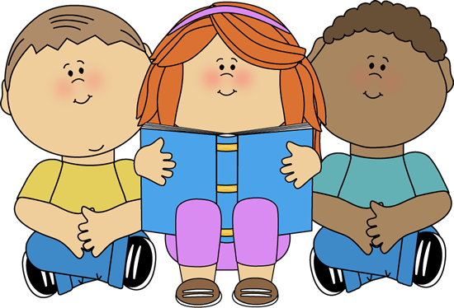
I need to have these 4 books in my book box:

1 Non-fiction book
1 Chapter book that is on my level
1 Challenge book that is above your level
1 book for fun (Trivia, facts)

